Genealogical update
(please complete and mail to: Tomasz Luszpinski, ul. Gubinska 8/62, 54-434 Wroclaw / Poland)

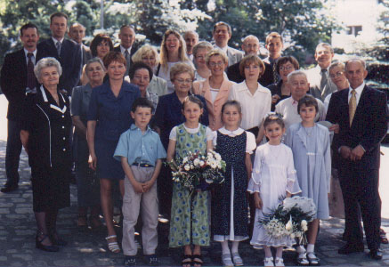

Please fill this form to your best knowledge.
If in doubt please include „?”, ie. „Name: ? Karl”.

Name ...................................................................... Surname ...........................................................................

Father ............................................................ Mother ........................................... Nee ...................................

Born date ........................... time ............ place .............................................. hospital ....................................

Baptized/Christened date ........................ place .............................. Church .....................................................

First Communion date ....................... place .............................. Church ...........................................................

Education ........................................ diploma / degree ......................................................................................

place ..................................................................................................... date ...................................................

Employed as ........................................ employer .......................................... place ..........................................

Retired date ......................................................................................................................................................

Married to ................................................................................. Nee ................................................................

- civil ceremony date ................................ Marriage Office place .........................................................................

- church ceremony date ............................. Church ........................................ place ..........................................

Divorced ..................................................................... date ..............................................................................

Married to ................................................................................. Nee ................................................................

- civil ceremony date ................................ Marriage Office place .........................................................................

- church ceremony date ............................. Church ........................................ place ..........................................

Children: Name and Surname date of birth other info (adoption, etc.)

1. ..................................................................... ...................... ........................................

2. ..................................................................... ...................... ........................................

3. ..................................................................... ...................... ........................................

4. ..................................................................... ...................... ........................................

5. ..................................................................... ...................... ........................................

6. ..................................................................... ...................... ........................................

Siblings: Name and Surname date of birth other info (other parents)

1. ..................................................................... ...................... ........................................

2. ..................................................................... ...................... ........................................

3. ..................................................................... ...................... ........................................

4. ..................................................................... ...................... ........................................

5. ..................................................................... ...................... ........................................

6. ..................................................................... ...................... ........................................

Height .............. cm; Weight .............. kg; Eye color .................................. Hair color ........................................

Died date ........................... place ................................................ Death cause .................................................

Burried date ........................ place ............................................ cementary .................................... no. .............

Other information ..............................................................................................................................................

.........................................................................................................................................................................

.........................................................................................................................................................................

.........................................................................................................................................................................

.........................................................................................................................................................................

.........................................................................................................................................................................

.........................................................................................................................................................................

.........................................................................................................................................................................

.........................................................................................................................................................................

Address ............................................................................................................................................................

.........................................................................................................................................................................

.........................................................................................................................................................................

.........................................................................................................................................................................

Phone ............................... Fax .............................. E-mail ................................ www.______________________

I am interested / not interested in my family genealogy (please cross out not applicable).

Place ............................., Date ............................. Signature ................................................................

